**What are we proud of in our school?**



Our supportive ethos and inclusive approach always shines through! There is always a feeling of care and warmth demonstrated throughout the school.

**The Governors of Coalway Community Infant School are particularly proud of the following achievements and successes over the past year**

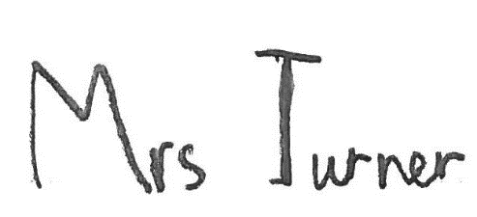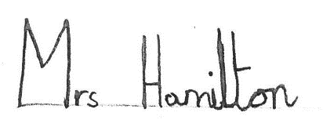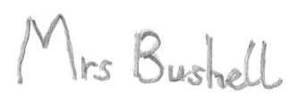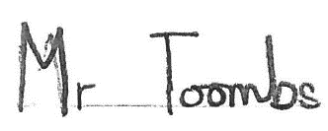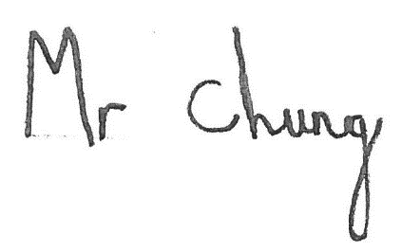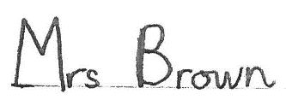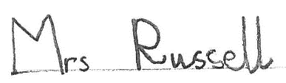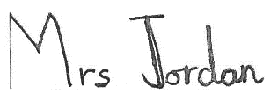

Whenever we have visited school this year the children have been enthusiastic, confident, focused, engaged, motivated, polite and most importantly happy!

Our staff are; excellent, committed, dedicated, approachable and put a lot of time and care into everything they do. They make the learning experience happy, fun and vibrant for our children.

The provision of support for the whole family continues to be a long standing commitment. This year we have managed to increase the Family Support Worker hours which has been invaluable in further supporting this priority of the school.

The achievements of the children; the majority of our children achieve significantly above national standards in reading, writing and maths. We are particularly pleased with our Year 2 SAT’s last year.

Our staff have received a significant amount of training this year to further develop our support for children with social, emotional and special educational needs. As a result a number of successful intervention programmes have been put in place across the school.

The children are well supported by adults within school, with a lot of 1:1 high quality support offered.

We have continued to invest in iPads and software.

READ bookmarks and badges have been very successful!

The introduction of our Coalway Experiences has opened up many opportunities and broadened curriculum experiences for all children, as well as being fun!

The support and interest shown by our parents such as with READ, Homework, attendance at parents’ evenings, school events and various functions including Harvest, Christmas, Concerts and the Summer Fayre.

The safety and security improvements made on site such as the mechanised entrance gates, improved fencing and entrance foyer.

We are very proud of our Reception team who have worked hard to gain the Bristol Standard accreditation.

The range of before and after school clubs that continues to be offered by the staff for the children.