Coalway Community Infant School
Coalway Road, Coleford, Gloucestershire GL16 7HL
Telephone: 01594 833457
admin@coalway-inf.gloucs.sch.uk
www.coalway-inf.gloucs.sch.uk
Head Teacher: Mrs. H. Alliston B.Ed (Hons)

A COMMUNITY SPIRITED PERSON URGENTLY WANTED
For approx. 6¼ hours per week at £10.90 ph. School term only
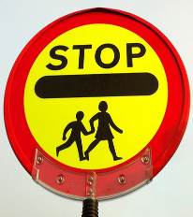
A School Crossing Patrol is urgently needed at Coalway Schools.
If you're reasonably fit and are available at the start and end of
the school day, then the Head Teacher would be very
pleased to hear from you.
Could you be responsible for the safety of children?
If you're interested, then please contact
Sarah Nash or Roz Edwards at
Coalway Community Infant School or Tel: 01594 833457

