**What are we proud of in our school?**





**We are pleased to note via feedback in our parent questionnaire that 100% of parents who responded would recommend our school to other parents.**

**The Governors of Coalway Community Infant School are particularly proud of the following achievements and successes over the past year**

**The School Council are always a delight to meet! Having this fantastic pupil voice, involvement and responsibility is so important; they are an excellent role model and portray the school ethos brilliantly. Their enthusiasm and confidence is infectious!**

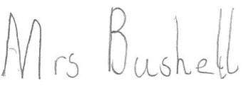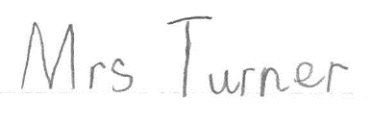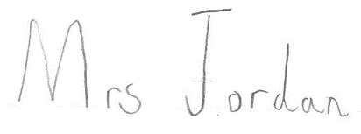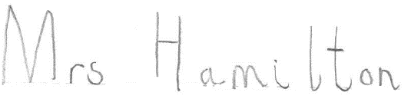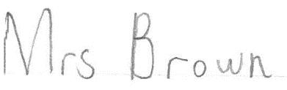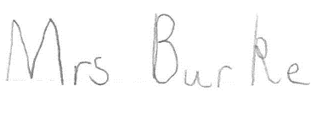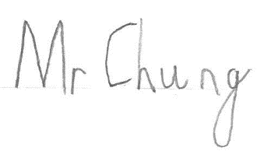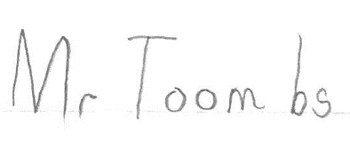

**We were delighted to be re-recognised as a Healthy School once again. This is the third successive time we have gained this award since 2013. Promotion of a healthy lifestyle and habits are important aims of ours and always evident whenever we visit school in things such as ‘Coalway Blast’, healthy eating and recycling practices.**

**School concerts continue to be a highlight for staff, children and parents, creating very special memories for all, as demonstrated in concert feedback received during the year.**

**Pupil voice tells us that the children really enjoy their learning!**

**We continue to keep our premises well maintained, with external and internal decoration, fire door replacement and minor repairs having been undertaken during the last year. Providing a high quality environment for our children and staff is essential to us.**

**We continue to commit a significant amount of funding to ensure our staff receive quality training in areas that further develop their knowledge and skills and meet the needs of our children. This year they benefitted from speech and language training amongst other things.**

**Our good financial management continues to enable healthy staffing levels and provide high quality resources and facilities for the children.**

**We are pleased to learn via external moderation feedback that our staff’s assessment judgements are secure, that they have high standards and a thorough understanding of their pupil’s achievements.**

**Our children’s attainment continued to be very high. Boys, girls and Pupil Premium pupils achieved well above national rates of attainment for these groups in Reading, Writing and Maths at the end of their time with us in their SATs.**

**The continued support and engagement from parents at events such as open evenings, parent’s evenings, concerts, Fayres, Sports Day, and support with reading & home learning.**

**Our excellent and wide ranging well-being practices and support were recognised when we received Gloucestershire’s Mental Health Champions Award. We were particularly pleased with the assessors comments that ‘emotional health and well-being are clearly embedded in all aspects of school life’ and that ‘they are not just a ‘bolt on’ to the school but are at the heart of the school environment as well as the community and important to everyone’.**

**We appreciate the continual hard work of all the staff which creates a really stimulating, engaging environment and curriculum for all the children. They continue to amaze us with their ideas and exciting and engaging topic work and themes.**

**This year we said goodbye to a long standing Governor, Mrs Kathy Russell, who has been supporting the school for the last 21 years. We thank her wholeheartedly for her commitment and support throughout this time.**