***I liked looking at the photos because they were all different.***

***The pictures were interesting. They were black and white so we knew it was long ago.***

***Mr Hook thought it was a musical instrument.***

***I knew it was a camera because I saw a TV show where they mended a camera and it was like it.***

***I liked holding the camera because I could see it better!***

***.***

***I thought it was an accordion because of the bellows.***

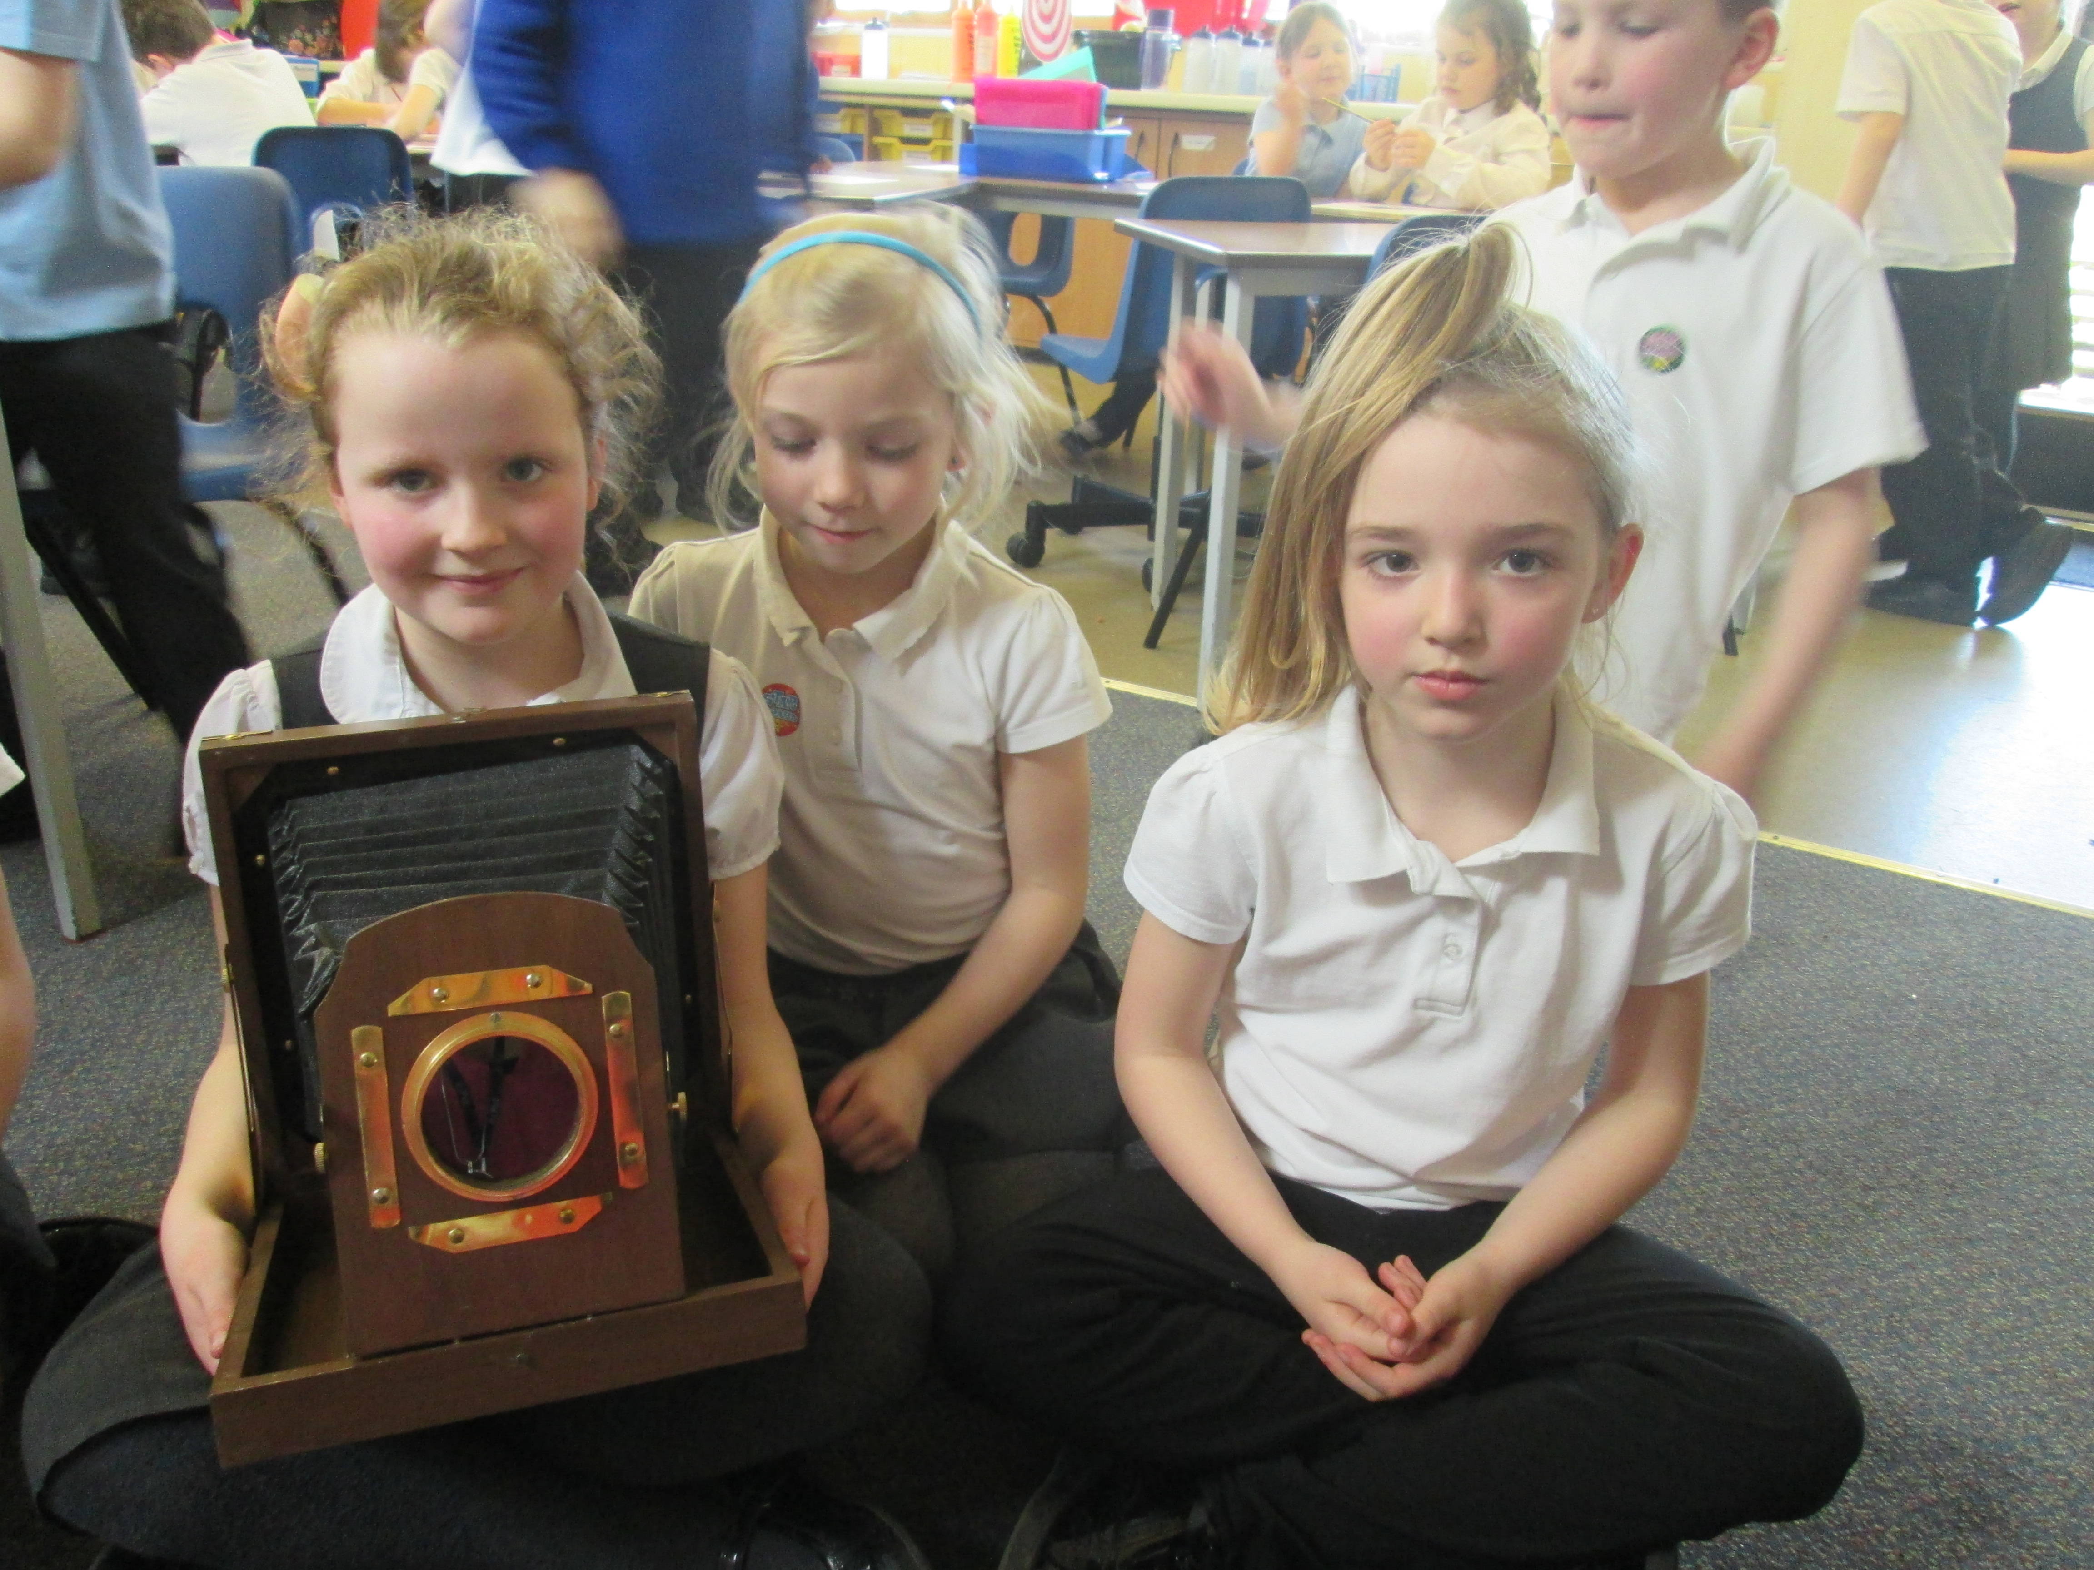

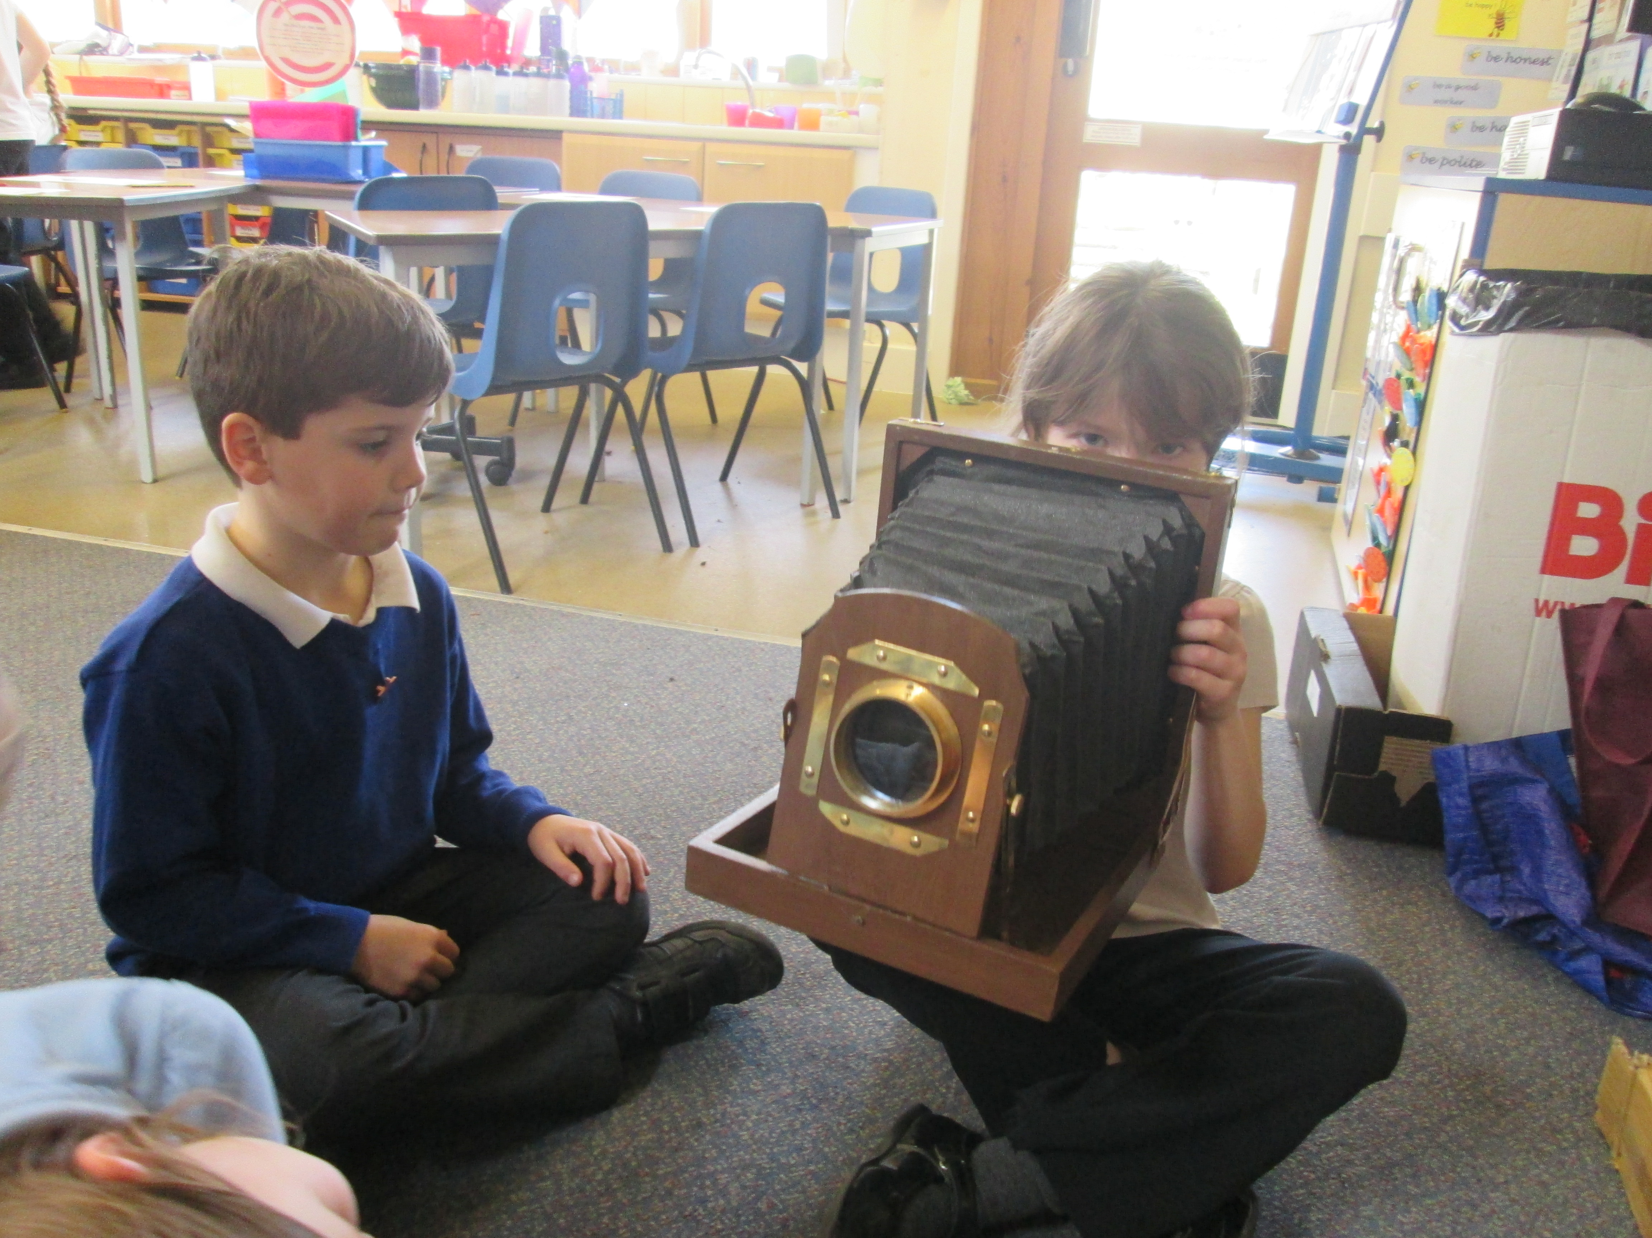

***‘History Day at Coalway’***

***Classes 5 and 6***