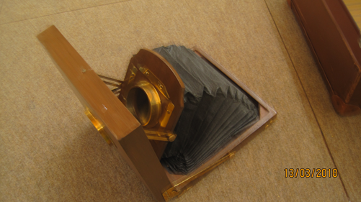

***It was interesting.***

***The camera was cool!***

***I want to do a History Day at home! We’re going to find out if my Great, Great, Great Uncle had a camera like that.***

***I liked holding the camera and touching it.***

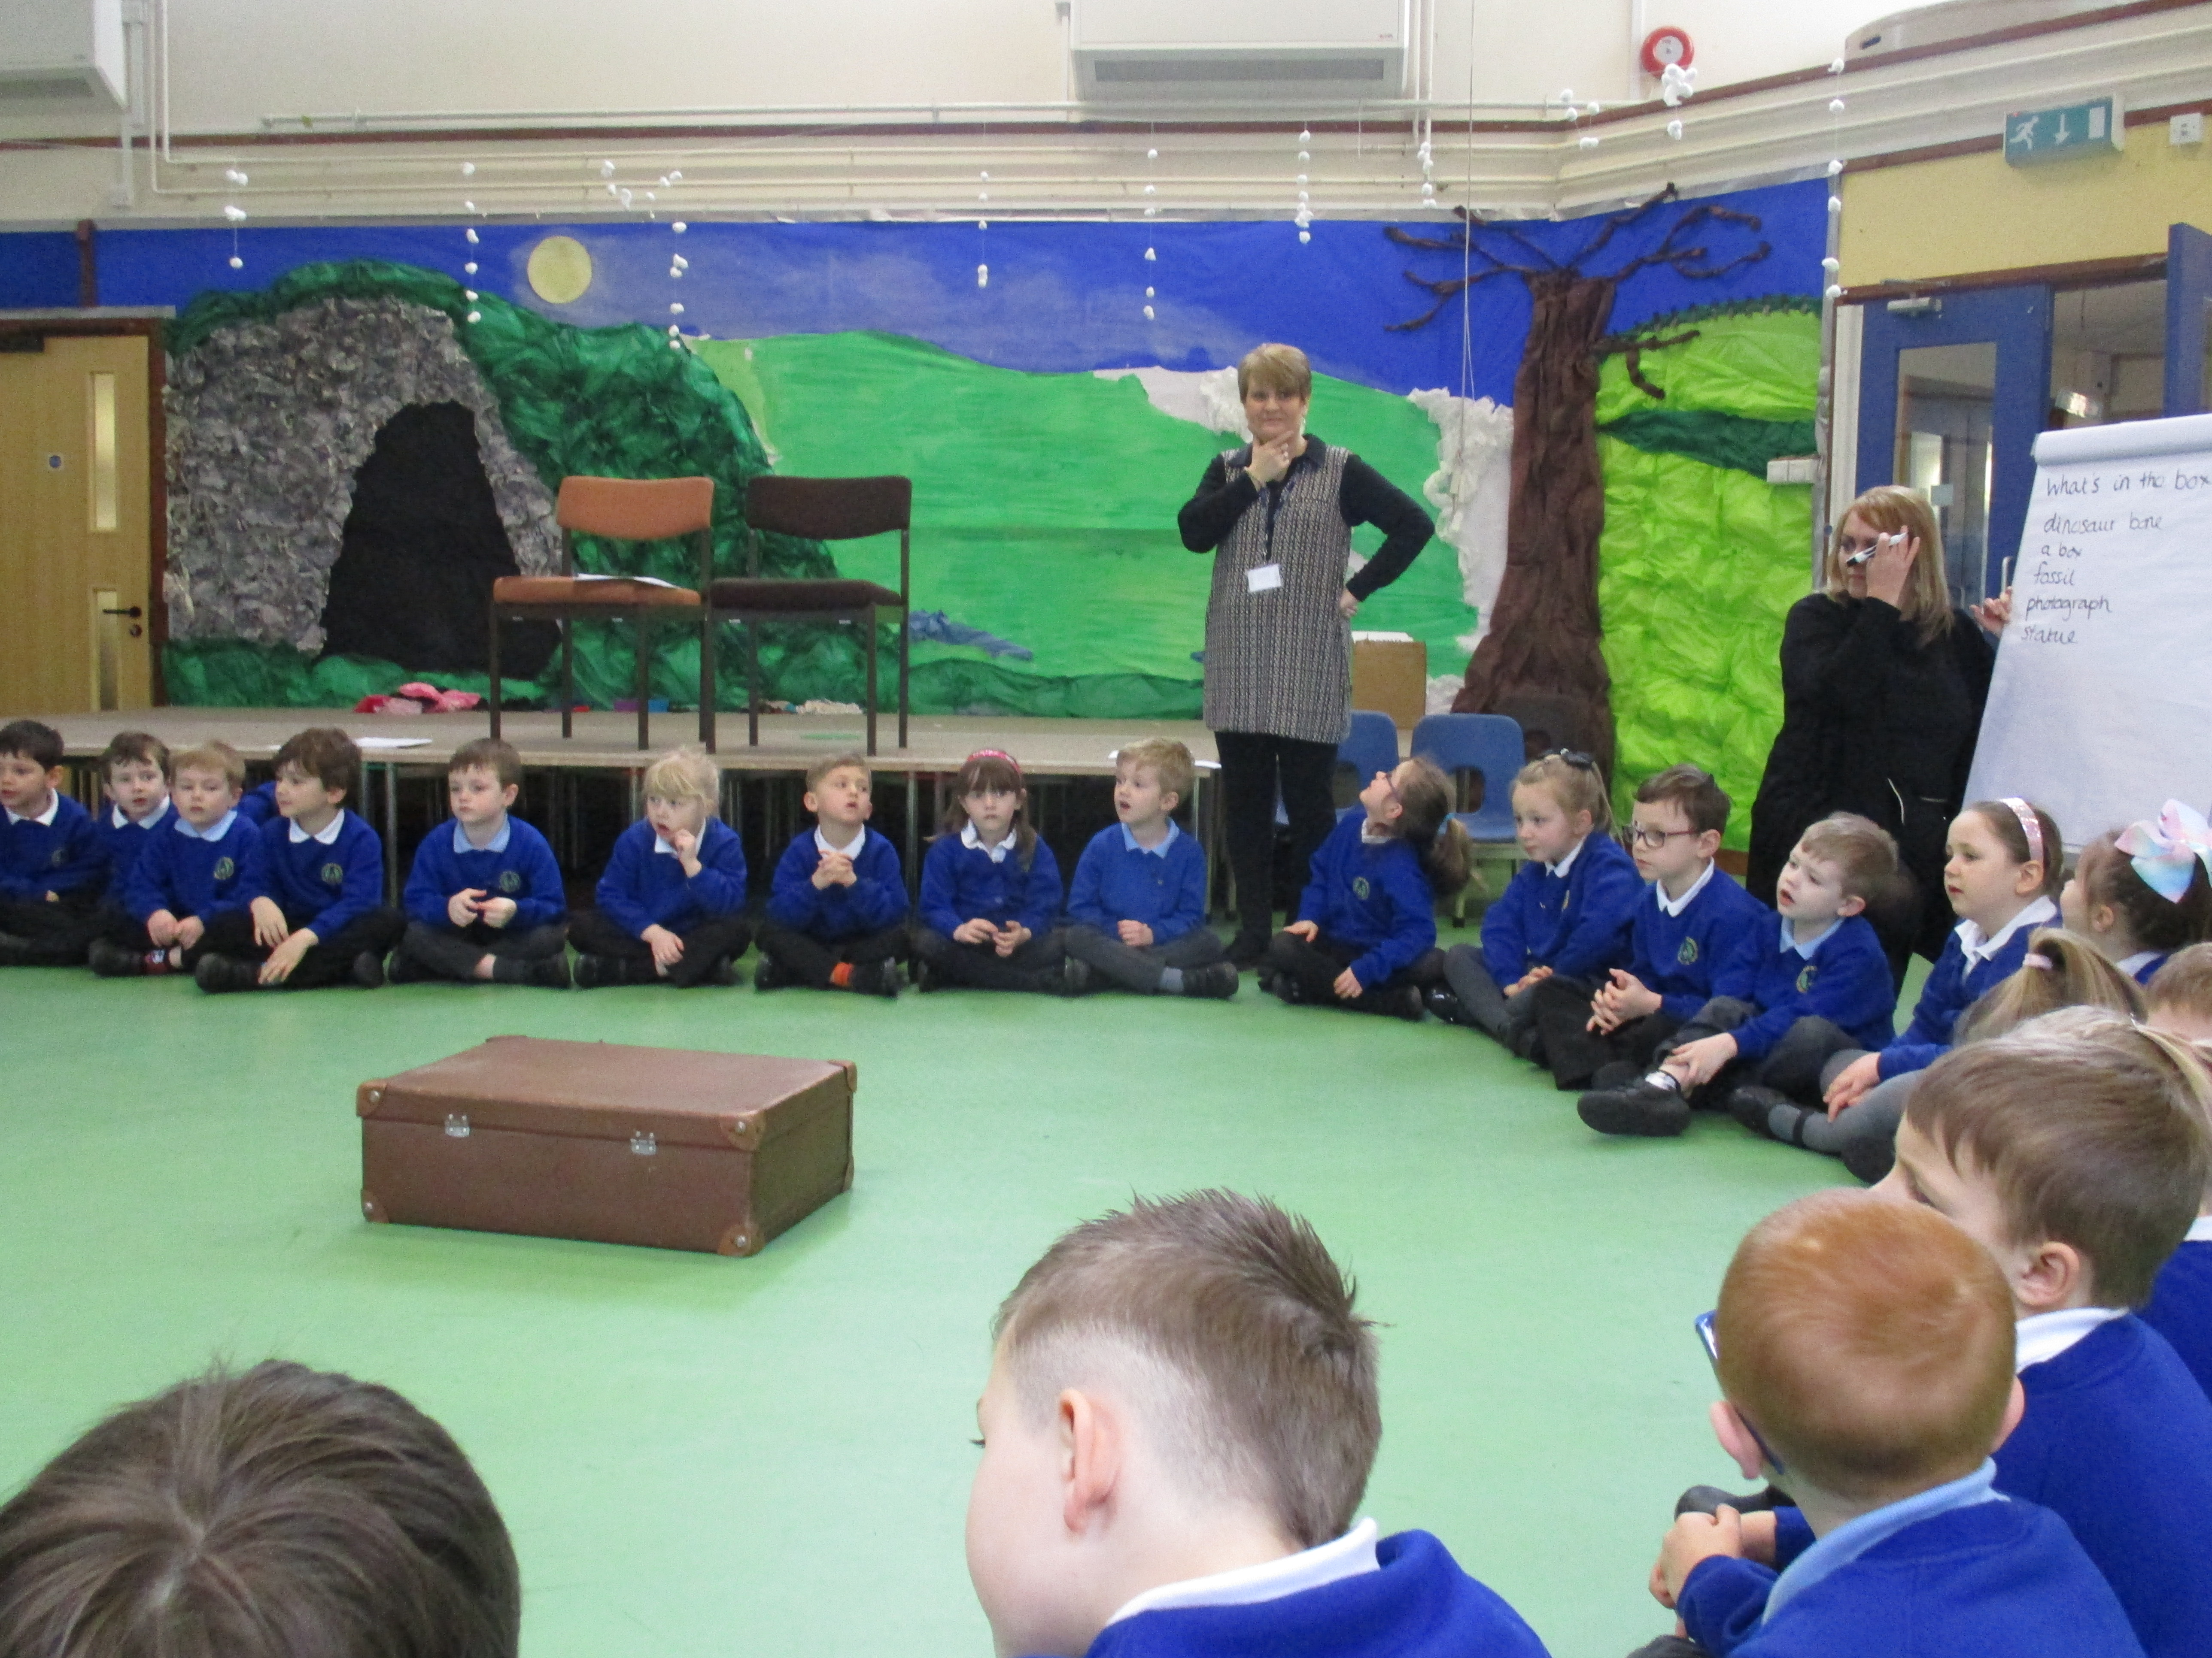

***It was tricky answering the questions because I hadn’t seen anything like that before.***

***History Day was really good! I told my Grandad all about it and he told me all about a camera like that one.***

***‘History Day at Coalway’***

***Classes 3 and 4***